Assessment of Students
OHIO RESIDENT EDUCATOR PROGRAM
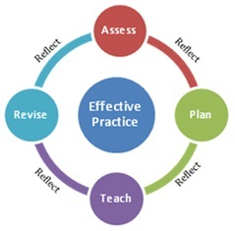
Intentional
Instructional Grouping

Purpose: Resident Educators should use flexible grouping strategies, grouping and regrouping students according to specific goals, learning activities, and individual needs. Groupings should be vary and include opportunities for both homogeneous and mixed-ability groupings.

Directions:
- Together, mentors and Resident Educators discuss the importance of flexible instructional grouping and review the data identified in the Class Profile.
- Resident Educators should complete the Inventory below, delineating one possible class grouping and providing a rationale for this particular arrangement.
- Following the activity for which this grouping was used, Resident Educators should add a reflective statement regarding the efficacy of this particular instructional grouping.

INTENTIONAL INSTRUCTIONAL GROUPING INVENTORY
Resident Educator: | Date Completed:
Grade Level/Subject Area:
Rationale for this Grouping:
Grouping:

Reflection on Efficacy of this Grouping:

